Sametime 9.0.1 – Crappy line arrangement

Environment:
Notes Standard Client 901_FP10IF3
Sametime embedded Client 9.0.1_ST_20170808-1337
Win10

Problem:
We are rolling out new PCs, new Notes at the moment and run into several issues.
This is one of them:

Notes 8.5.x with Sametime 8.5.2 IFR1 and ALL PREVIOUS NOTES/SAMETIME versions!
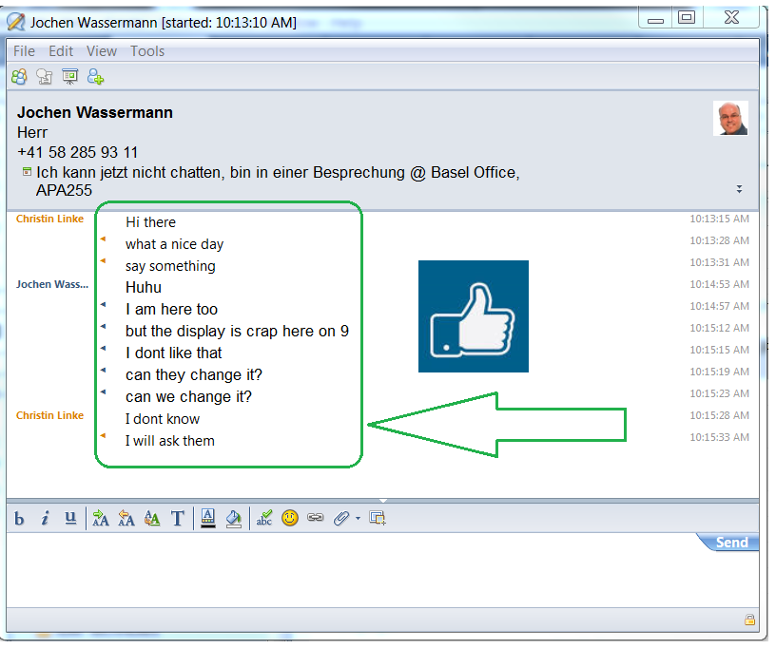

New with Notes 9.0.1 and Sametime 9.0.1
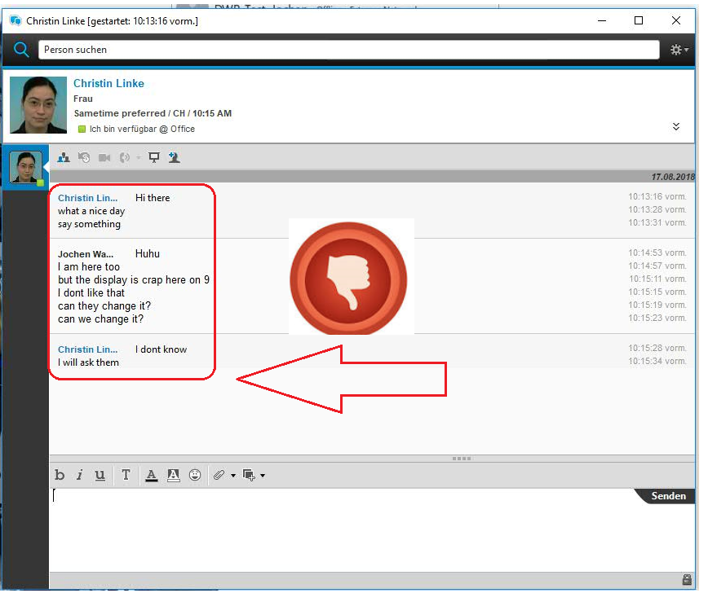

As this is obviously not an improvement, it is meant as a feature or bug?
And how to fix it???
My users are complaining loudly and I fully second them.

My preferred contact method is via mail. Phone is no use thanks to Softphone.

Thanks a lot in advance.

