Steps perform to reproduce the custom LtpaToken key problem for sametime.

1. Created Custom LtpaToken key WAS servre

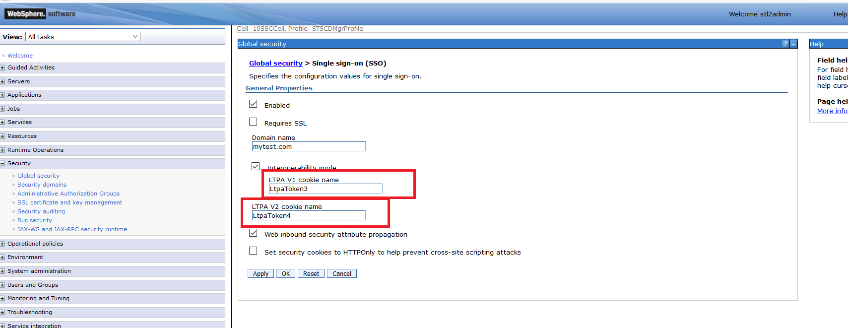

1. Set password for LTPA and exported key in path .

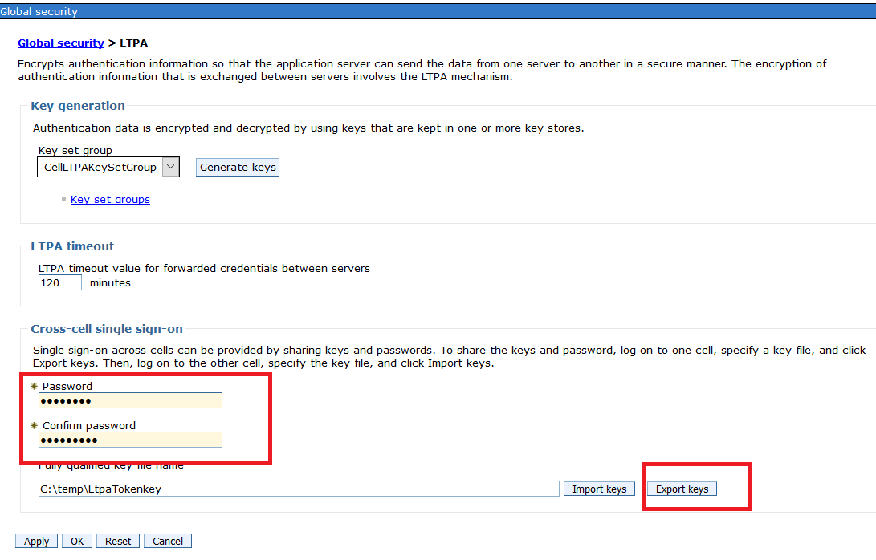

1. Imported key in Domino Web SSO document and set Ltpa **Token Custom Cookie name LtpaToken3 &** Ltpa Token2 Custom Cookie name: **LtpaToken4 &** save the Web SSO configuration document 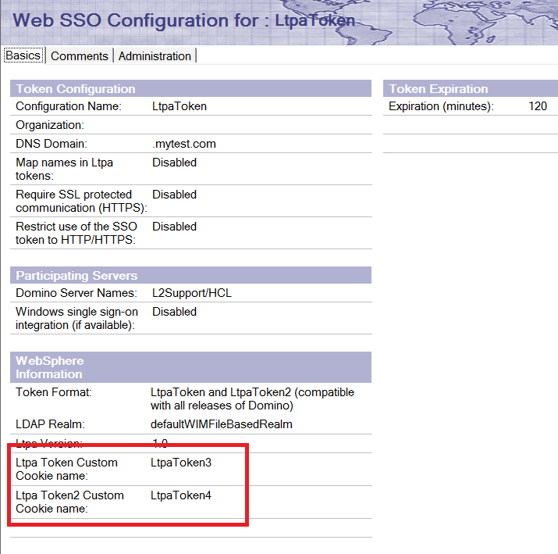
2. Restarted domino server
3. Started Media, meeting & proxy server.

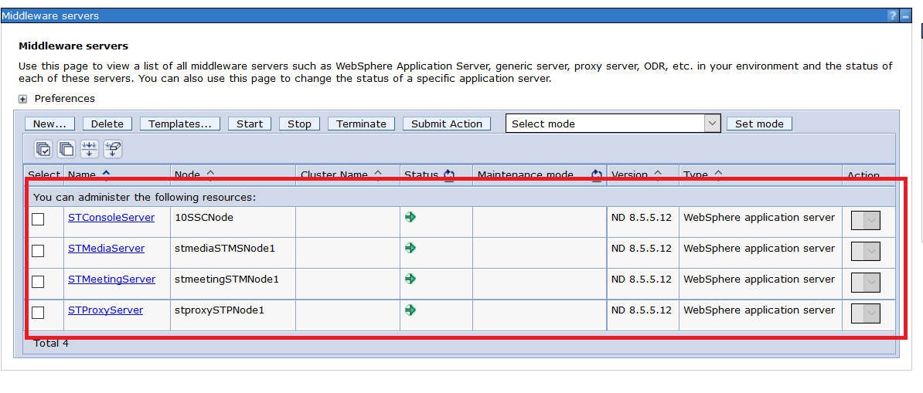

1. Login in sametime client through proxy server . We able to login in sametime through proxy server but still we are not getting cookies name like LtpaToken3 & LtpaToken4 . Instead this getting default name LtpaToken & LtpaToken2.

<http://stproxy.mytest.com:9081/stwebclient/index.jsp>

1. Able to login in sametime through proxy

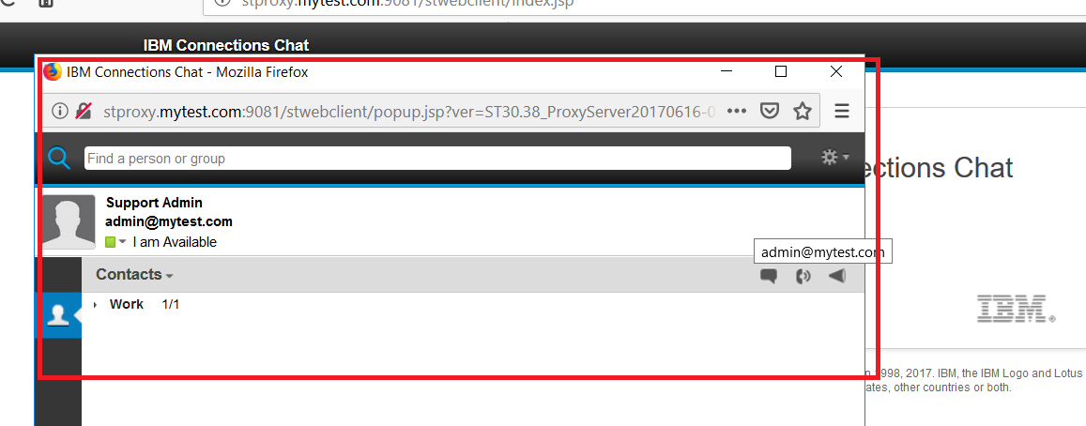

1. When we see the cookie name in browser debug mode getting default LtapToken key name which should not expected in when we changed cookies key name to LtpaToken3 & LtpaToken4 . expecting custom cooikes name should appeared .

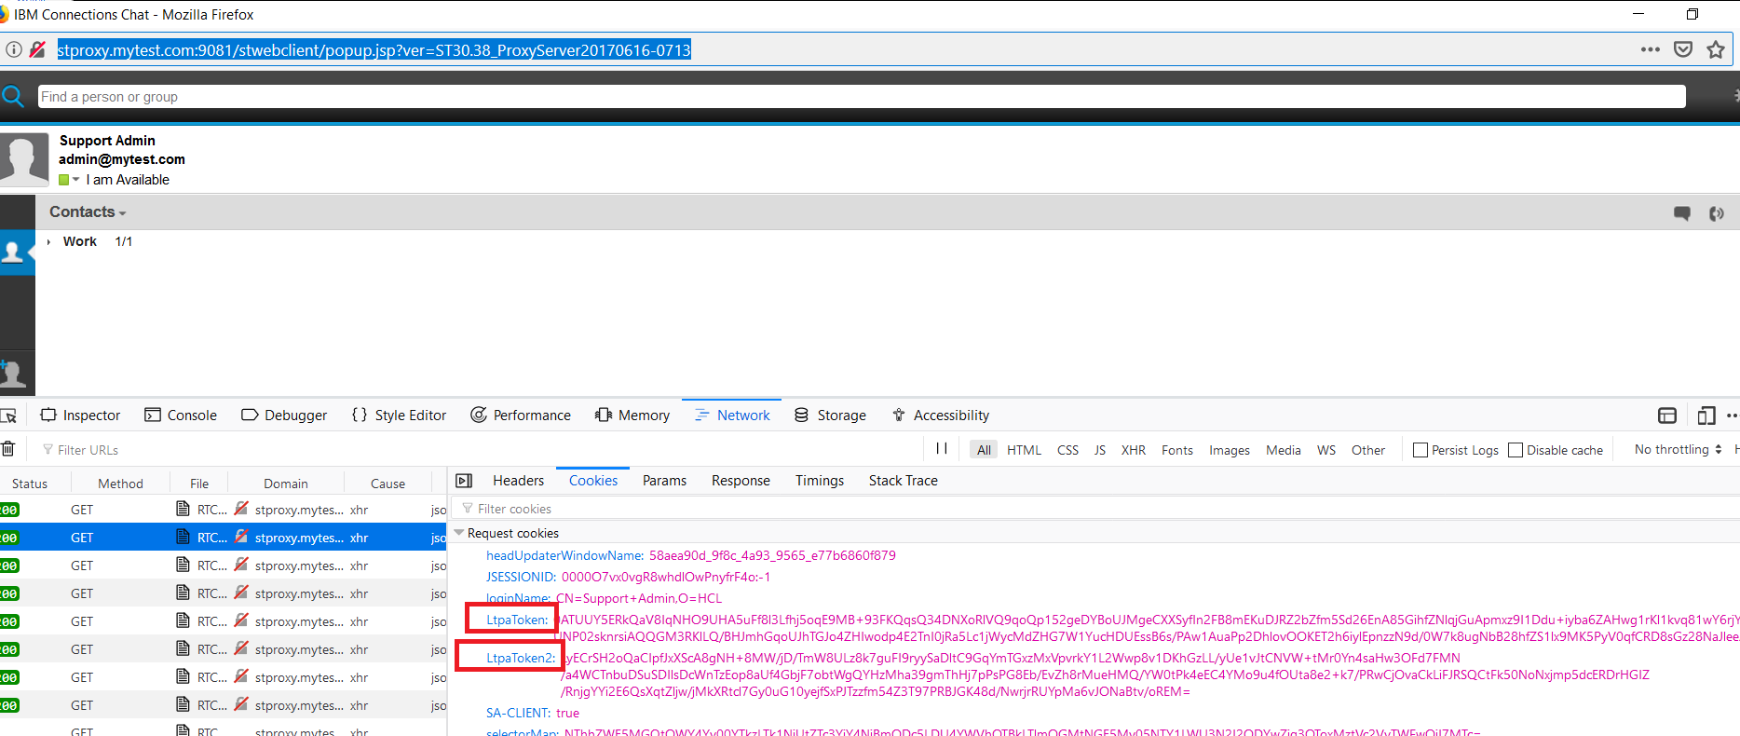

1. Checked by login in meeting URL where we able to see the custom cookies name as expected .
2. Able to login in meeting server

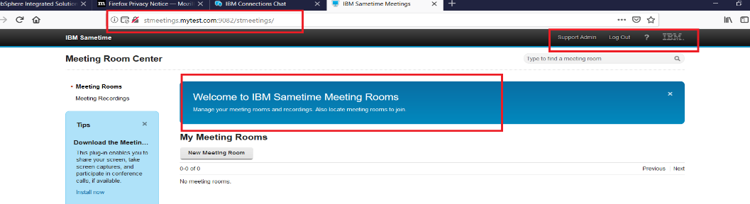

1. Clear browser cookies and done fresh login and pressed Fun+F12 to open the browser in debug mode and can see the cookies

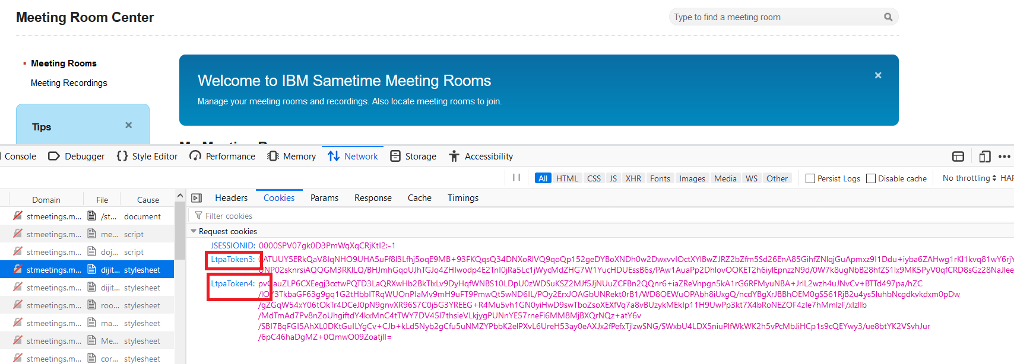

Problem :

1. Customer using inhouse developed application and using Ltpatoken & Ltpatoken2 key cookies for that application.
2. Due to this reason customer wants to use another name in WAS server LtpaToken key name. but when we login in sametime through proxy it picked up default cookies name (Ltpatoken & Ltpatoken2) and customer can not access both sametime & inhouse application in same browser.
3. If customer login in inhouse application cookies get downloaded with name (Ltpatoken & Ltpatoken2) and if customer login in sametime with same browser he will not able to login because cookies will not matched and login get failed.
4. If cookies name will be different like ( Ltpatoken3 & Ltpatoken4) then customer can use inhouse application and sametime in same browser.