Word one: 𦦵 used Chinese font file 

Word two: ※ used Chinese font file 

Reproduce steps:

1. New a Notes mail document
2. Copy the both special DBCS characters 𦦵※ into to, cc, bcc, subject and body field.
3. You can see the two special DBCS characters copy into mail body field as two block as image. That display wrong.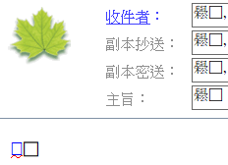
4. @ the two special DBCS characters , type a return key then as second image with correctly DBCS display after type a key @DBCS righ side. 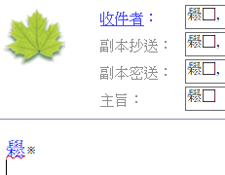

My Problem is Rich-Text field can’t auto-switch correctly for the both DBCS characters.

PS: to, cc, bcc, subject are plain-text fields that can’t display both font type.

Below image show this problem all the same as Notes client for each version.

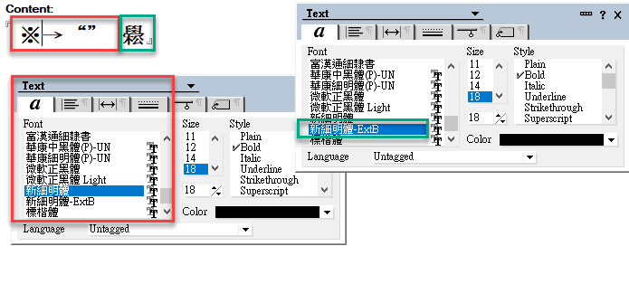 <<R11

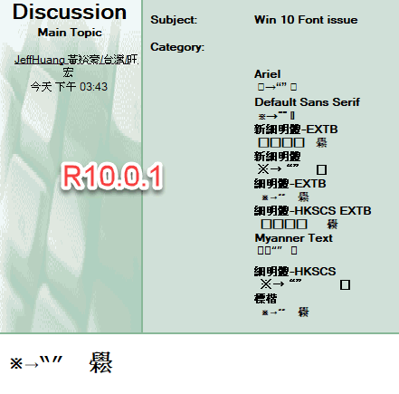

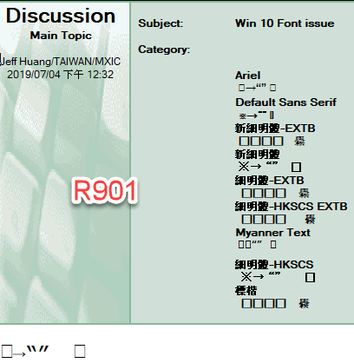 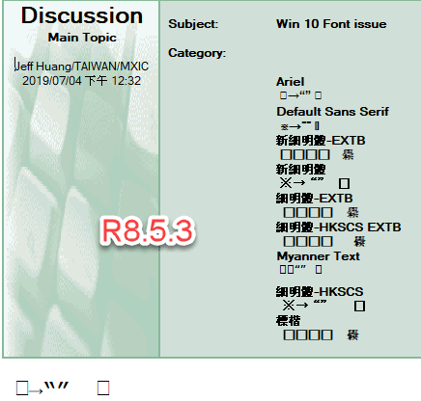 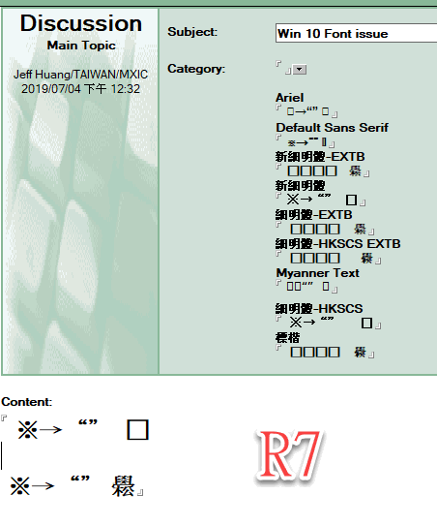

Suggest:

The both special DBCS characters work well for Microsoft word, excel. Because Microsoft support DirectWrite.

為什麼在 Windows 10 上某些應用程式中，某些文字會顯示成方形方塊？   
reference

[https://msdn.microsoft.com/zh-tw/library/windows/apps/hh700394.aspx#recommended_fonts](https://apc01.safelinks.protection.outlook.com/?url=https%3A%2F%2Fmsdn.microsoft.com%2Fzh-tw%2Flibrary%2Fwindows%2Fapps%2Fhh700394.aspx%23recommended_fonts&data=02%7C01%7CShunyuan.cheng%40hcl.com%7C8111fe6b5e2a443b5f5708d731d5236e%7C189de737c93a4f5a8b686f4ca9941912%7C0%7C0%7C637032663822688675&sdata=fhDkBk%2FN7upzI3MIhgweXCXVTZ3cHODuHGAGH3nInBI%3D&reserved=0)  
[https://support.microsoft.com/zh-tw/help/3083806/why-does-some-text-display-with-square-boxes-in-some-apps-on-windows-1](https://apc01.safelinks.protection.outlook.com/?url=https%3A%2F%2Fsupport.microsoft.com%2Fzh-tw%2Fhelp%2F3083806%2Fwhy-does-some-text-display-with-square-boxes-in-some-apps-on-windows-1&data=02%7C01%7CShunyuan.cheng%40hcl.com%7C8111fe6b5e2a443b5f5708d731d5236e%7C189de737c93a4f5a8b686f4ca9941912%7C0%7C0%7C637032663822678680&sdata=1NISEaZY5BSENu4oEqIYeHNhuBKgxr5mIlKStOnIy24%3D&reserved=0)  
文章中列出的字型保證在所有的 Windows 10 裝置上都會存在。  
  
如果您的應用程式使用 DirectWrite，您可能需要考慮利用 DirectWrite 提供的字型後援機制。 即使您正使用較低層級 API，且想要執行自己的字型後援實作，DirectWrite 具有 API 來提供預設的對應，可讓您補充自訂的對應。 請參閱以下重要 API 的 MSDN 文章：  
  
· IDWriteFontFallback： [https://msdn.microsoft.com/zh-tw/library/windows/desktop/dn280450(v=vs.85).aspx](https://apc01.safelinks.protection.outlook.com/?url=https%3A%2F%2Fmsdn.microsoft.com%2Fzh-tw%2Flibrary%2Fwindows%2Fdesktop%2Fdn280450(v%3Dvs.85).aspx&data=02%7C01%7CShunyuan.cheng%40hcl.com%7C8111fe6b5e2a443b5f5708d731d5236e%7C189de737c93a4f5a8b686f4ca9941912%7C0%7C0%7C637032663822688675&sdata=UwdlwV1lCCouEQ8vYwKUQiL%2FwU0lH1pKKwJKeoUohRk%3D&reserved=0)  
  
· IDWriteFactory2::GetSystemFontFallback： [https://msdn.microsoft.com/zh-tw/library/windows/desktop/dn280450(v=vs.85).aspx](https://apc01.safelinks.protection.outlook.com/?url=https%3A%2F%2Fmsdn.microsoft.com%2Fzh-tw%2Flibrary%2Fwindows%2Fdesktop%2Fdn280450(v%3Dvs.85).aspx&data=02%7C01%7CShunyuan.cheng%40hcl.com%7C8111fe6b5e2a443b5f5708d731d5236e%7C189de737c93a4f5a8b686f4ca9941912%7C0%7C0%7C637032663822688675&sdata=UwdlwV1lCCouEQ8vYwKUQiL%2FwU0lH1pKKwJKeoUohRk%3D&reserved=0)  
  
· IDWriteFontFallbackBuilder： [https://msdn.microsoft.com/zh-tw/library/windows/desktop/dn280476(v=vs.85).aspx](https://apc01.safelinks.protection.outlook.com/?url=https%3A%2F%2Fmsdn.microsoft.com%2Fzh-tw%2Flibrary%2Fwindows%2Fdesktop%2Fdn280476(v%3Dvs.85).aspx&data=02%7C01%7CShunyuan.cheng%40hcl.com%7C8111fe6b5e2a443b5f5708d731d5236e%7C189de737c93a4f5a8b686f4ca9941912%7C0%7C0%7C637032663822698665&sdata=vR0xdLca2NIPVWHlKX1bYJoRsxLRA%2FkFEdliAlDUGnk%3D&reserved=0)