In VoP, at the left side where I can see all my folders, I have all folder tools that I need.

I can create, rename and delete a folder and I can create a subfolder

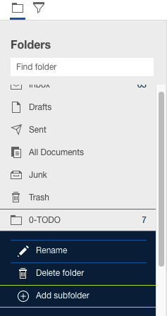

When I’m in an email, and I want to file this email in a folder, I can do this in an existing folder



I can create a folder



But I can’t create a subfolder