The user receives an email with many attachments with the same name: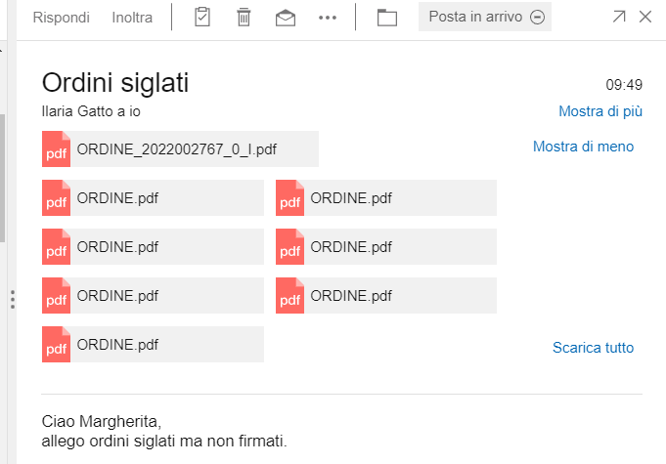

Giving the command DOWNLOAD ALL the files are renamed as follows It should name them with Order1,ORDER2,etc.