1. User1 click **New Email** to create one mail from **HTMO client**.

To himself and Cc one internal User2.

In the mail body, Click **Insert -> Pictures**，add one picture1 (such as: image1.png) from this device. Then click the **Send** button.

2. User1 open the received mail from Inbox, click **Forward** button.

To himself and Cc one internal User2 again.

In the mail body, copied one picture2 (such as: image2.png) from **Paint** and pasted it here. Then click the **Send** button.

3.User1 open the forward mail from Inbox:

Which could not show the picture2 on the forward mail, which display one thumbnails for the picture1.

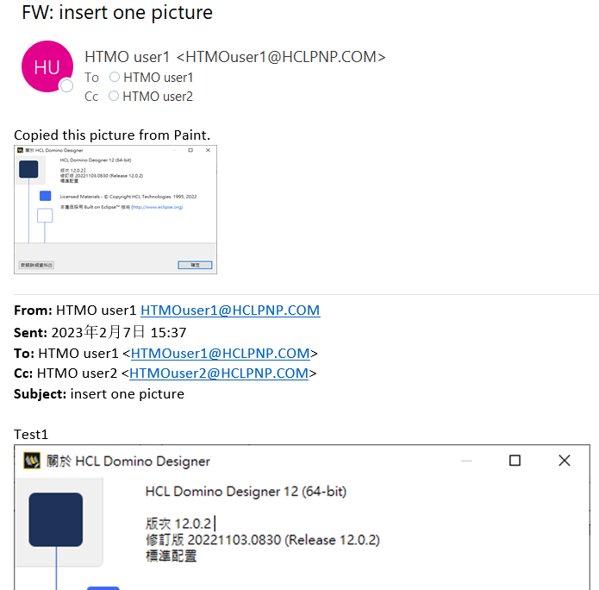

**Which work well when open the forward mail from Notes client.**

