Feature request to allow for post install and/or post upgrade “setup” screen actions to be invoked through a service call. We have a mandate that all production changes be done using our Urban Code Deploy (UCD) tool. See screen capture below.

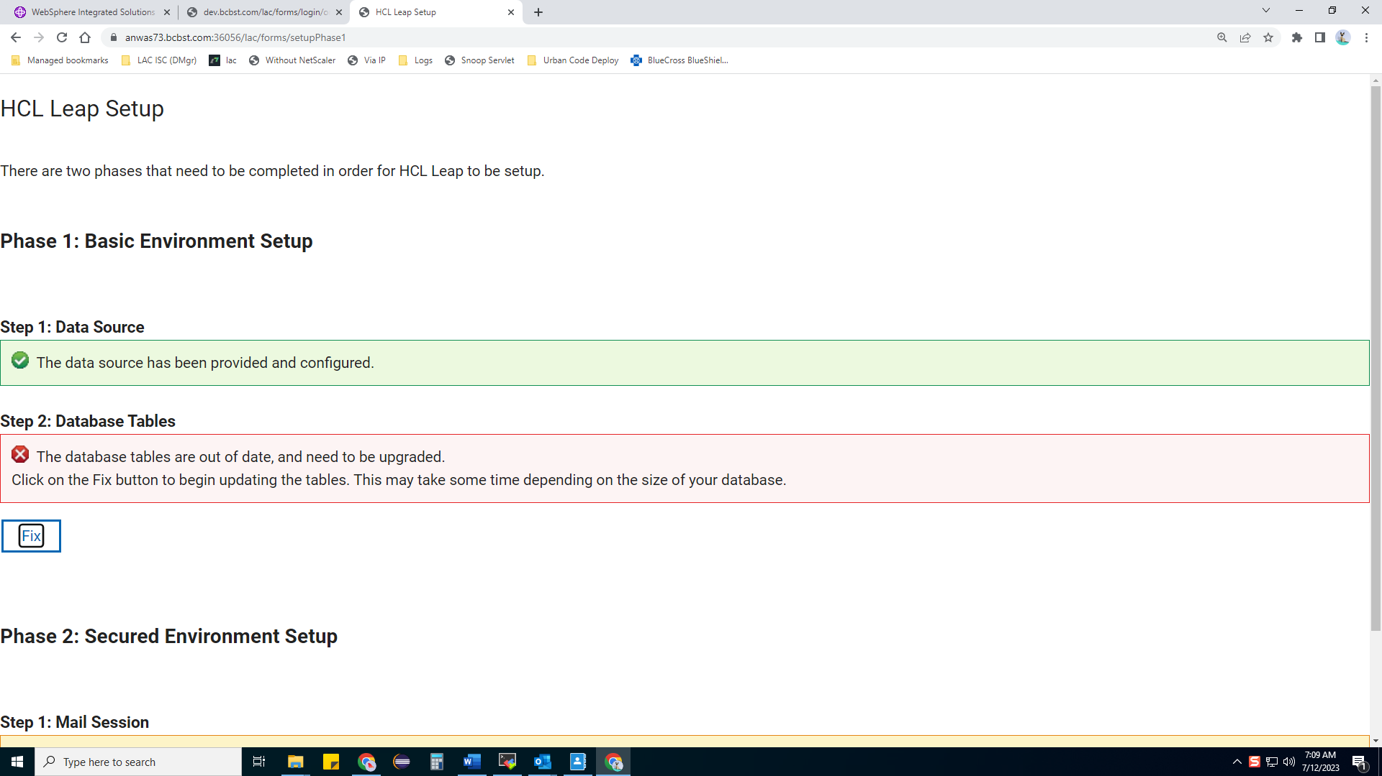

Figure of 3

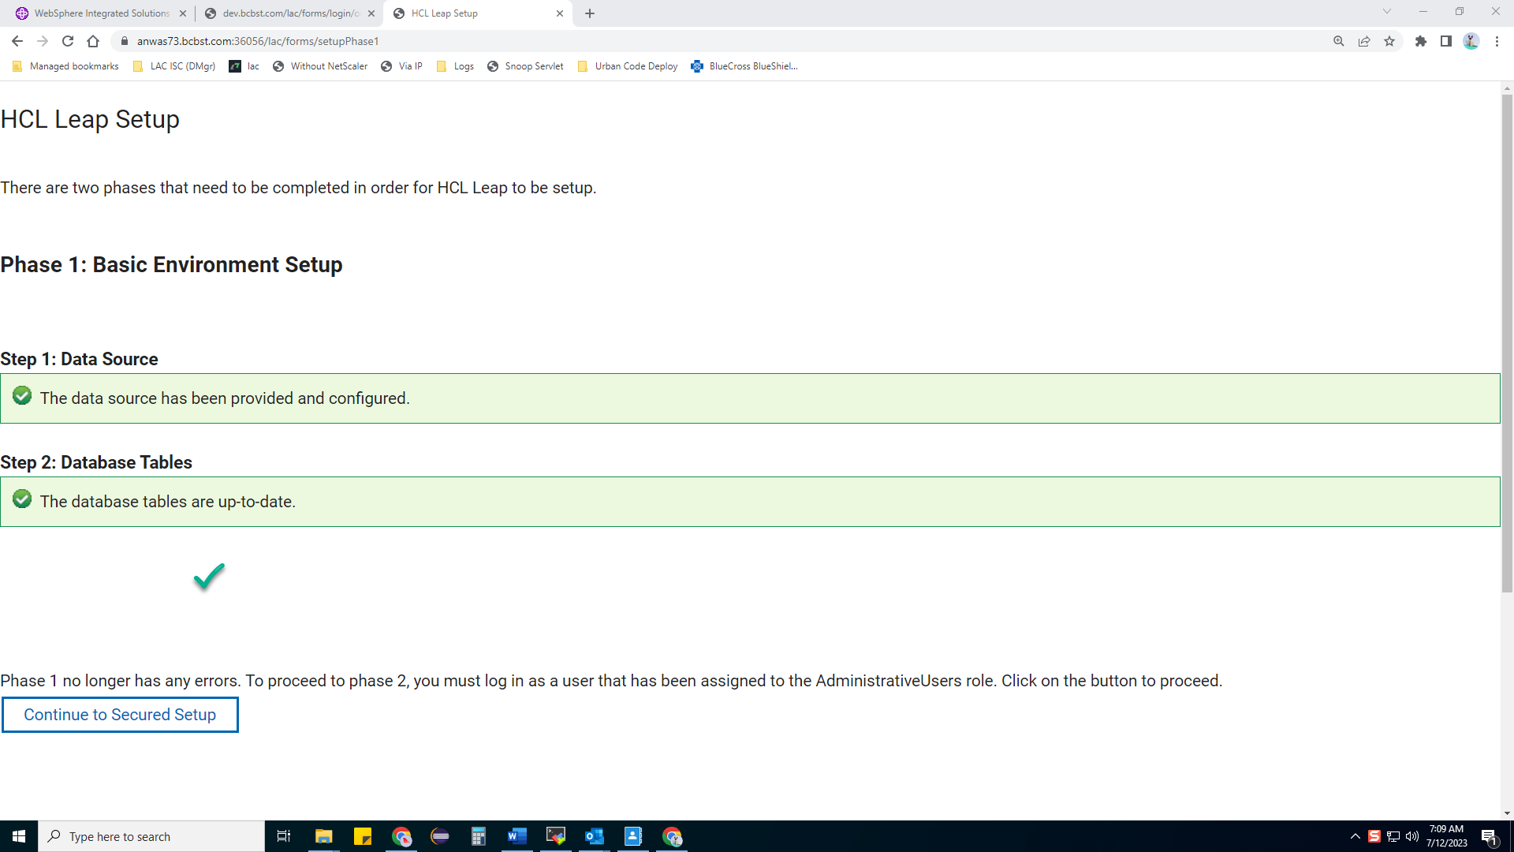

Figure of 3

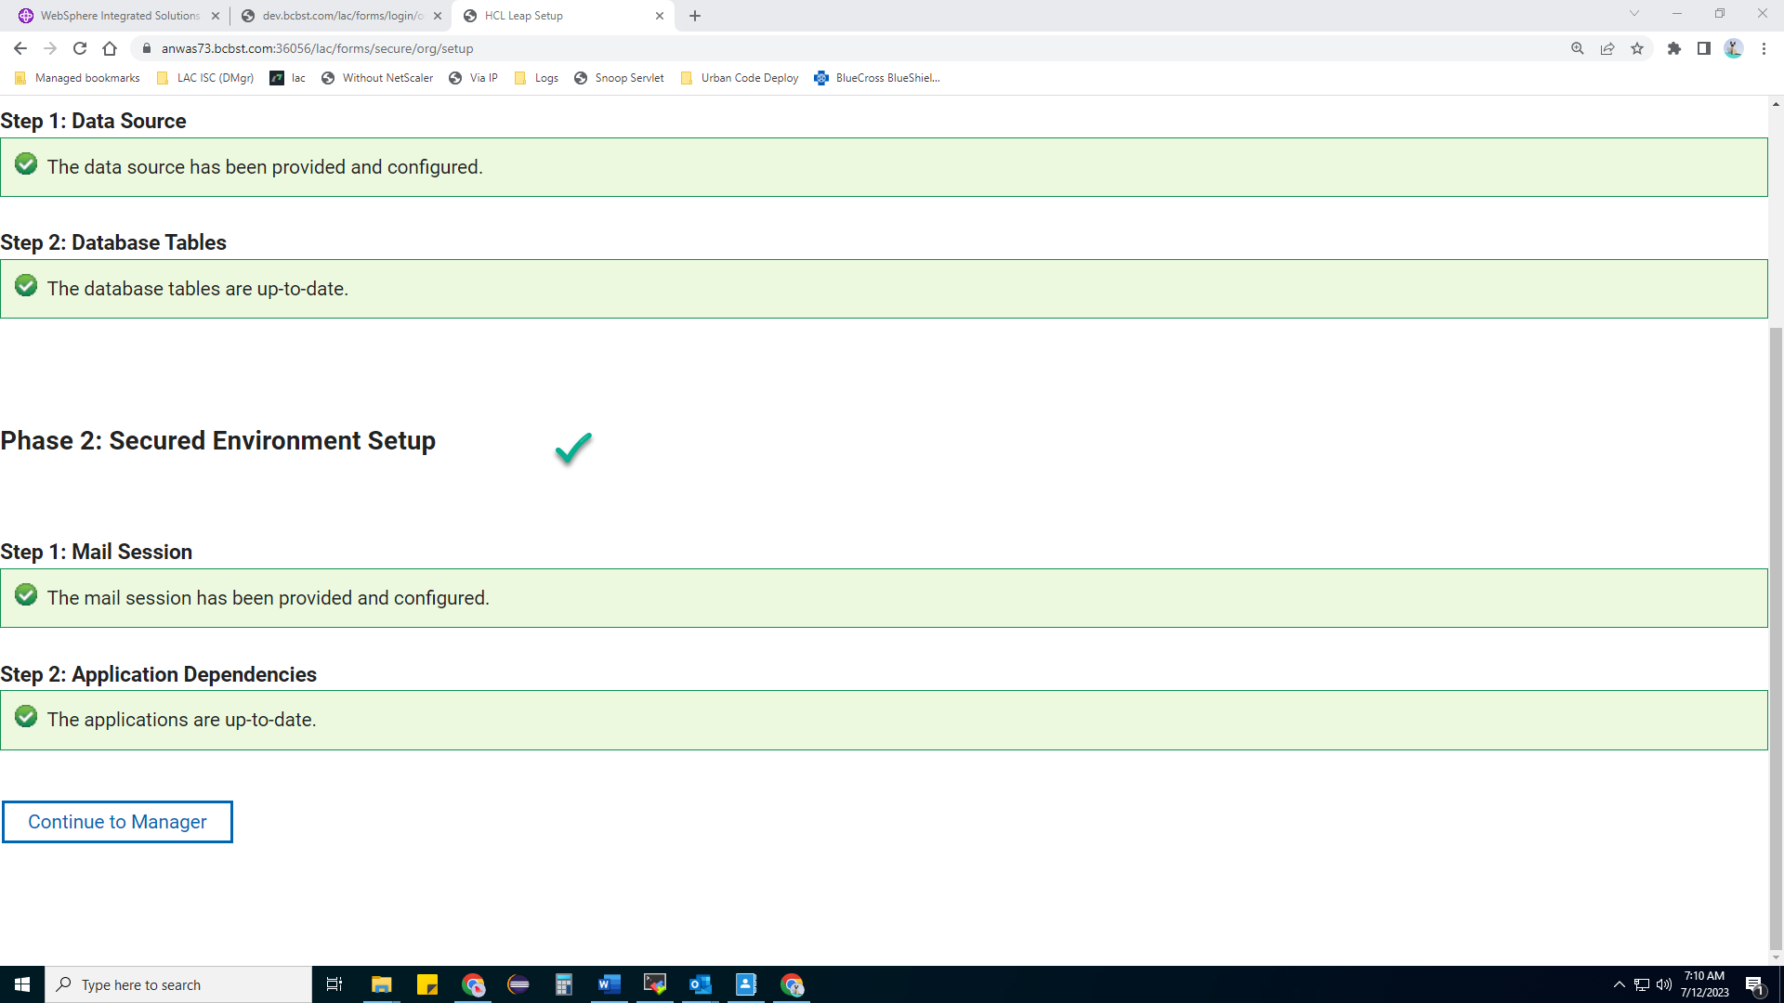

Figure of e