**Hide Vars in Javascript Script libraries (previous versions):**

1) Click Window > Reset Perspective…

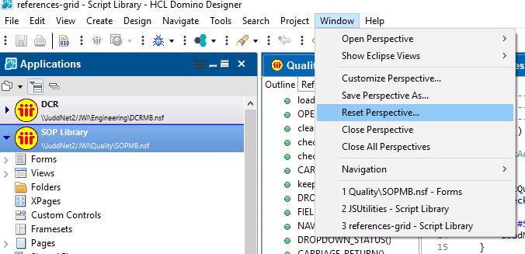

2) Open a JavaScript Script Library and right click –Open With – JavaScript Editor.

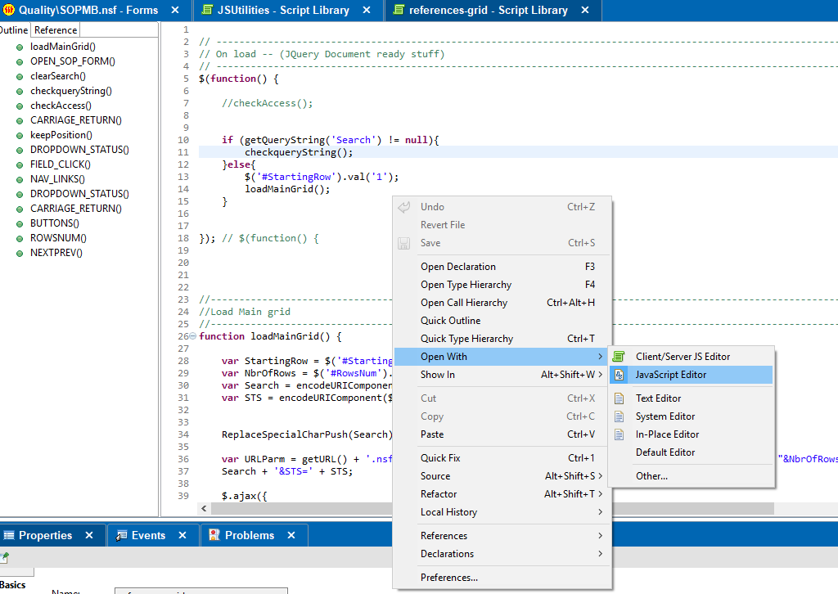

3) Click the Second icon (Hide Vars) in the Outline.

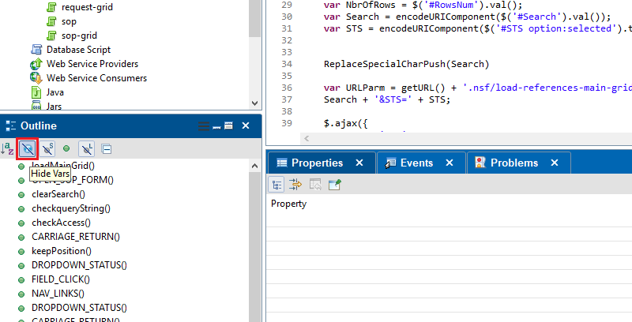

4) You may need to close Lotus Notes.

**Designer Script Library (Javascript editor) new fomat:**

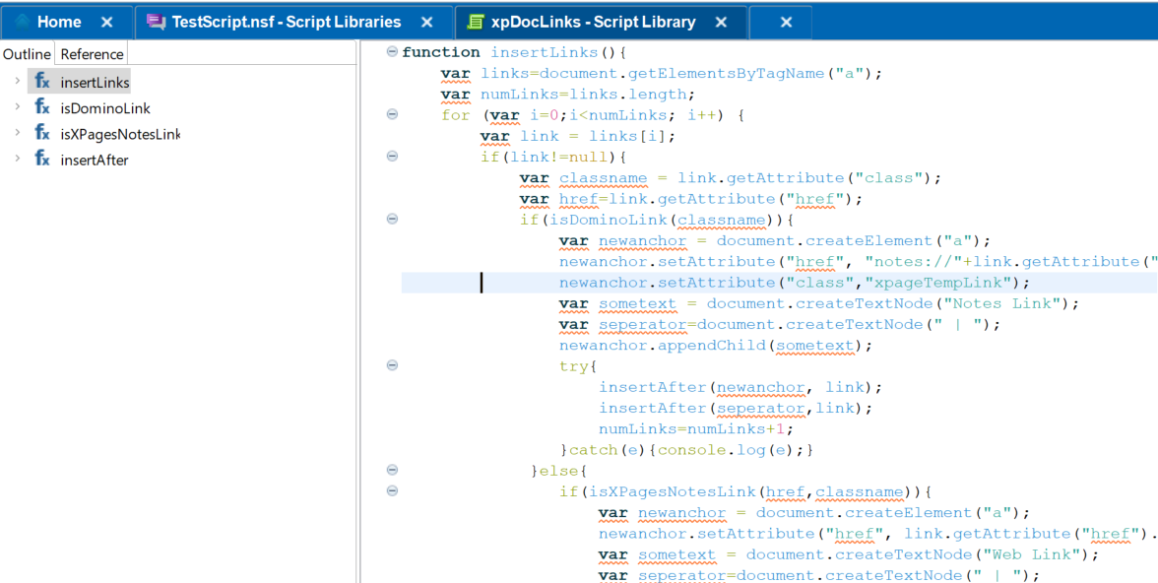

Hiding or getting rid of the Fx and all the sub details under it is not possible as the “Hide Vars” is not available.